System Constraints Analysis

This tool, downloaded from the BEAM Exchange, is part of the MSA Toolkit. It is a template guiding users to develop a constraint heatmap and prioritize them following certain criteria. Pros: It is a simple tool to help prioritize system constraints. Cons: It is not clear what criteria informed prioritization, plus the categories are limited to core and supporting functions and rules/norms.
Use the suggested structure below to start building your prose; update throughout the MSA Process and copy & paste into your final MSA report.

Step 1: System Constraint Heatmap
- Make a list of all of the constraints identified during the market assessment.
- Organize the constraints you identified into core functions (supply and demand), supporting functions, and rules/norms. See example below.
- Rate the constraints into significant, moderate and low categories in terms of negatively impacting the functioning of the market system.
- Create a table for each market system investigated

Key
Significant | Moderate | Low

Market System: [INSERT]
Core Function | Supporting Functions | Rules/Norms
Supply | Supporting Function 1 | Rules / Norms 1
[Insert constraint & colour. Add as many rows as required.]
Demand | Supporting Function 1 | Rules / Norms 2

Example: Hug Khao Report
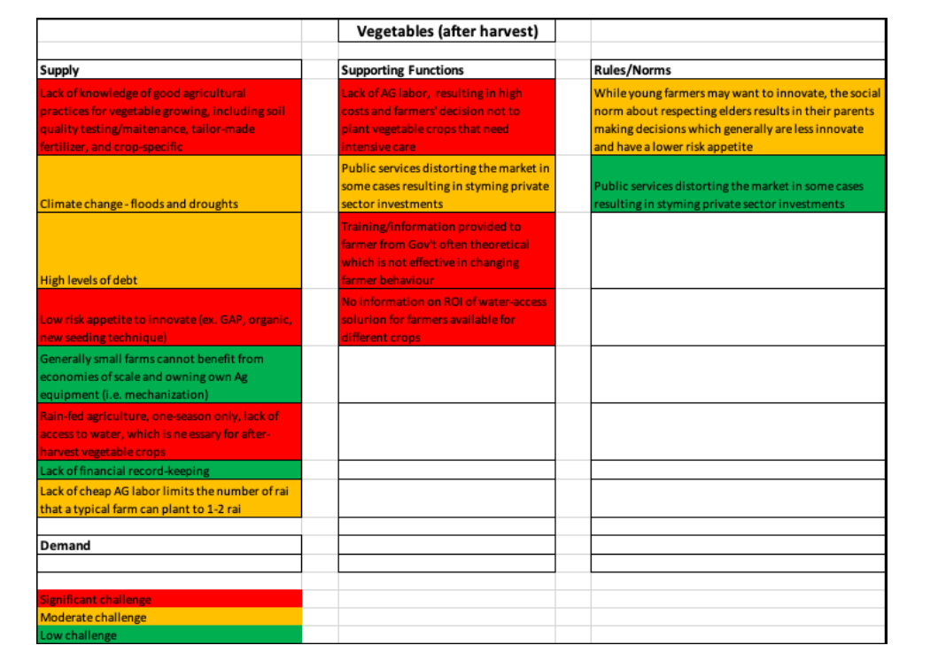

Step 2: Prioritize Constraints
Based on the above analysis of the market system, this section identifies and justifies which constraints (as defined above) the program will (initially) try to address through interventions, and which constraints it will not (or, at least, not initially) try to address.
The prioritisation is based on the following (but amend for your project specifically and note prioritisation criteria the MSA Report):
- Feasibility: is there a realistic possibility that the constraint can be changed/removed, based on the drivers and blockers of change? Are there future changes / trends in political economy, environment, technology etc that could affect the constraint being addressed?
- Impact: what would the impact of change to this constraint be (based on approximate projections)?
- Sequencing: determine whether there is any interdependence between constraints: whether one system-level constraint needs to be addressed before another?
- Importance: are there key issues important to this program and target group e.g. women and youth economic empowerment; conflict resolution; environmental protection; resilience building etc that the constraint will address
- Other relevant factors.

- List your selected prioritization criteria
Prioritization Criteria | Description Logic
Feasibility
Impact Potential
Sequencing
Importance
Other (if required)

- Map constraints and provide justification of prioritized constraints against the criteria
Constraint | Justification  (priority) | Feasibility | Impact | Sequencing | Importance
MARKET SYSTEM NAME
[insert constraint] | [insert conclusion] | H | M | L | M
MARKET SYSTEM NAME

- Map non-prioritized constraints and provide justification
Constraint | Justification  (non-priority)
MARKET SYSTEM NAME
[insert constraint]
MARKET SYSTEM NAME

